***Experiment 8***

**Aim:** Agile Sprint Planning: Conduct a simulated sprint planning session following agile principles, where students break down user stories into tasks, estimate their effort, and allocate them for a sprint.

**Sprint Planning:**

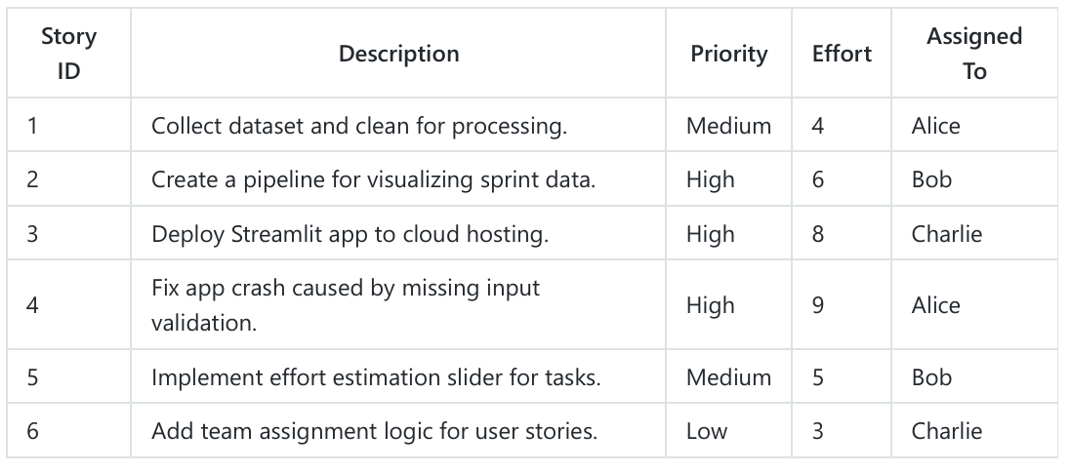

***Fig 1: Running Sphinx Commands***

***Fig 2: Output Sphinx Documentation***

***Fig 1: Agile Sprint Planning***

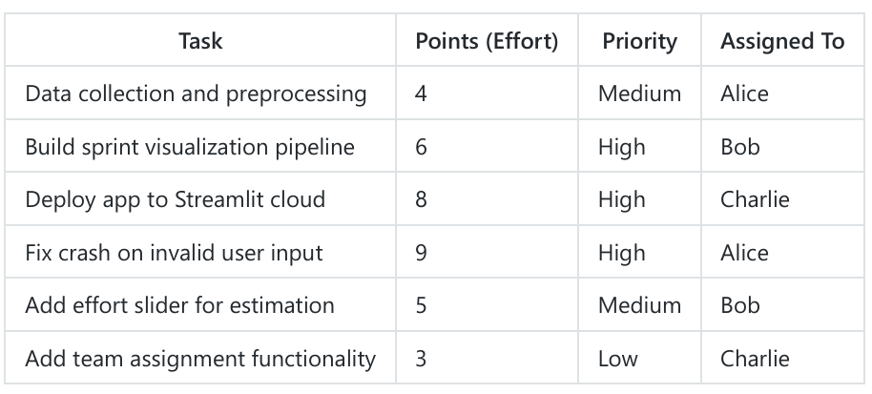

***Fig 2: Outp***

**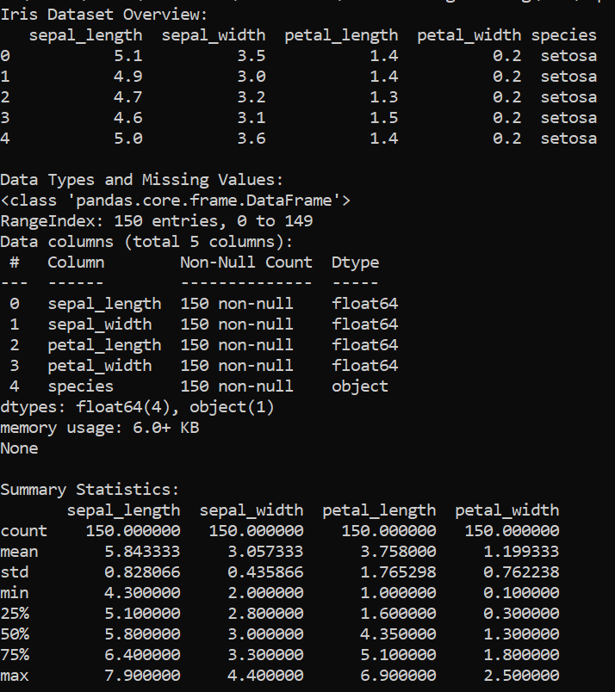*Fig 2: Generated Sprint Workflows***

***Fig 3: Iris Data Analysis in Python (First Sprint Task)***

***Fig 4: GitHub Repository(Second Sprint Task):*** [***Live Link***](https://github.com/madhurimarawat/Agile-Sprint-and-Iris-Data-Explorer)

***Fig 5: GitHub Repository Documentation (Third Sprint Task)***

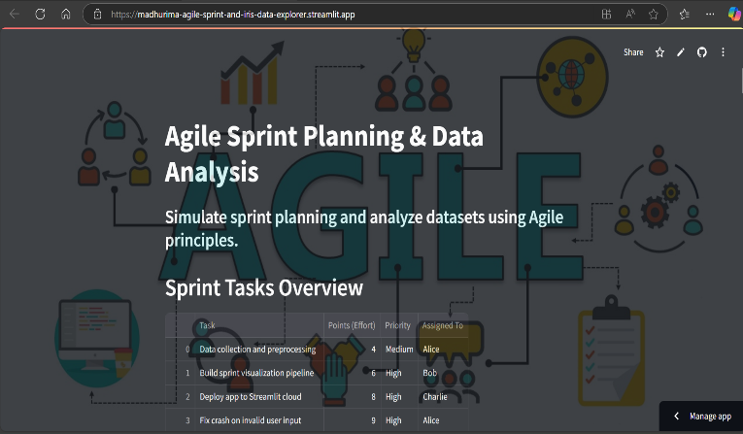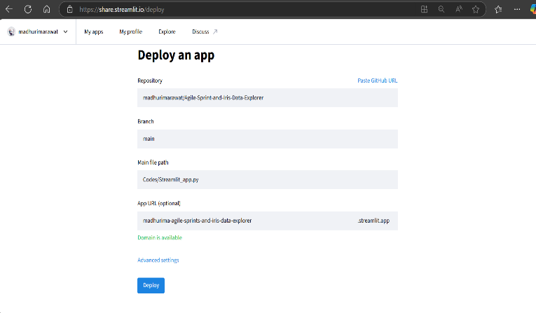

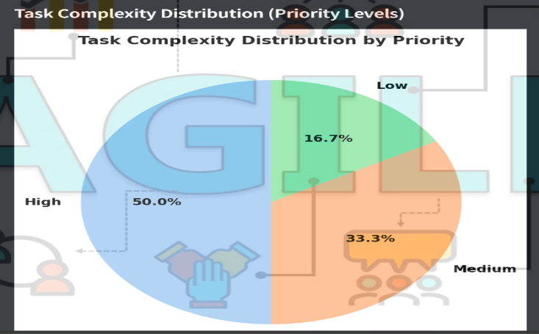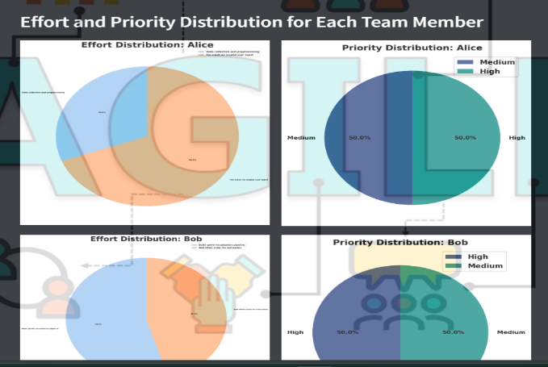

***Fig 7: Deployed Streamlit App (Fifth Sprint Task):*** [***Live Link***](https://madhurima-agile-sprint-and-iris-data-explorer.streamlit.app/)

***Fig 6: Streamlit Deployment(Fourth Sprint Task)***

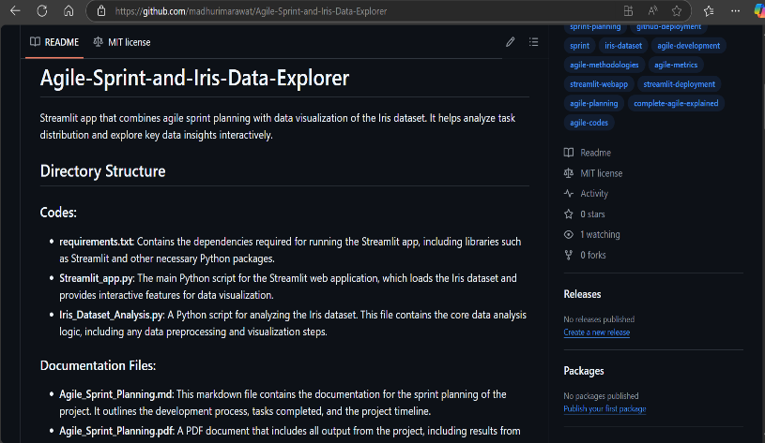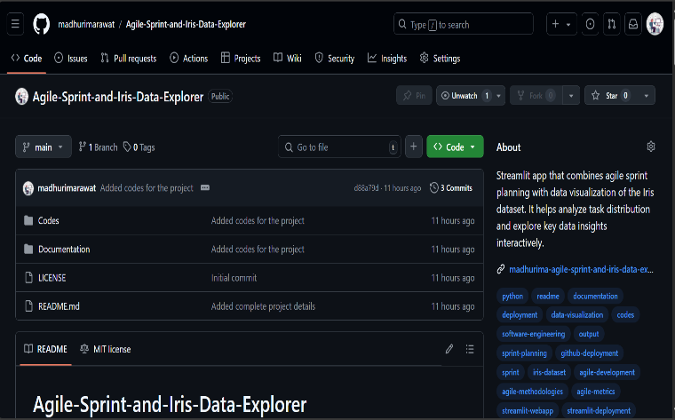

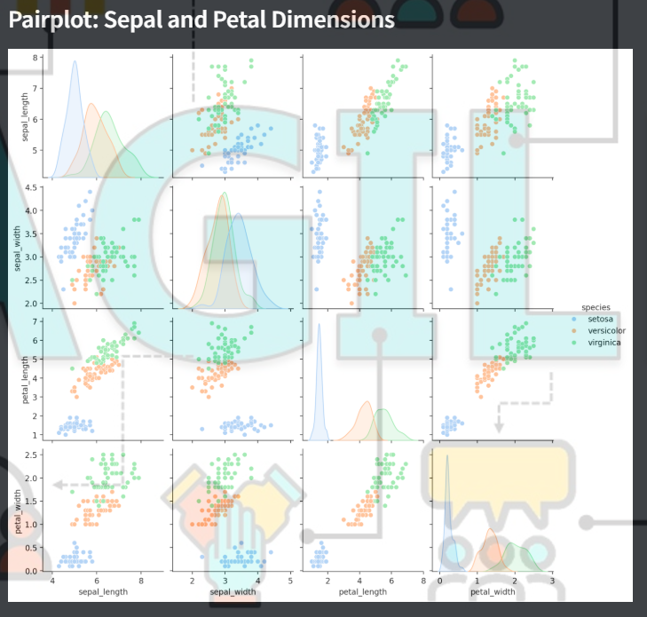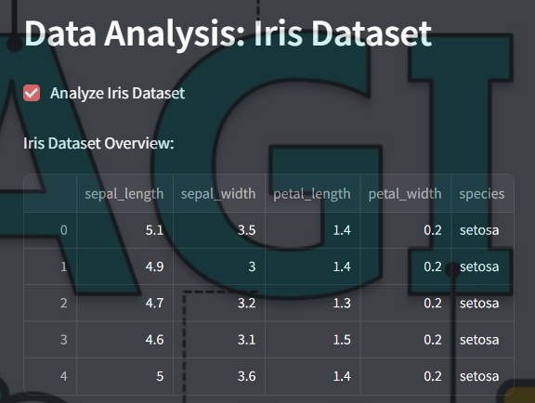

***Fig 9: Streamlit Deployed App View 3***

***Fig 8: Streamlit Deployed App View 2***



***Fig 11: Streamlit Deployed App View 5***

***Fig 10: Streamlit Deployed App View 4***